BUSINESS QUESTION AND VISUALIZATION REPORT
Team ID: | MCA
Project Name: | Smartphone usage, Digital Addiction & Well-Being Analytics
Maximum Marks: | 5 Marks

Project Definition & Scope
Visualization development refers to the process of creating graphical representations of data to facilitate understanding, analysis, and decision-making. The goal is to transform complex datasets into visual formats that are easy to interpret, enabling users to gain insights and make informed decisions. Visualization development involves selecting appropriate visual elements, designing layouts, and using interactive features to enhance the user experience. This process is commonly associated with data visualization tools like Microsoft Power BI, and it plays a crucial role in business intelligence, analytics, and reporting.
Business Questions and Visualizations
1. What is the average daily screen time when categorized by gender?
- Visualization: Column chart comparing average daily screen time hours for Male, Other, and Female categories.

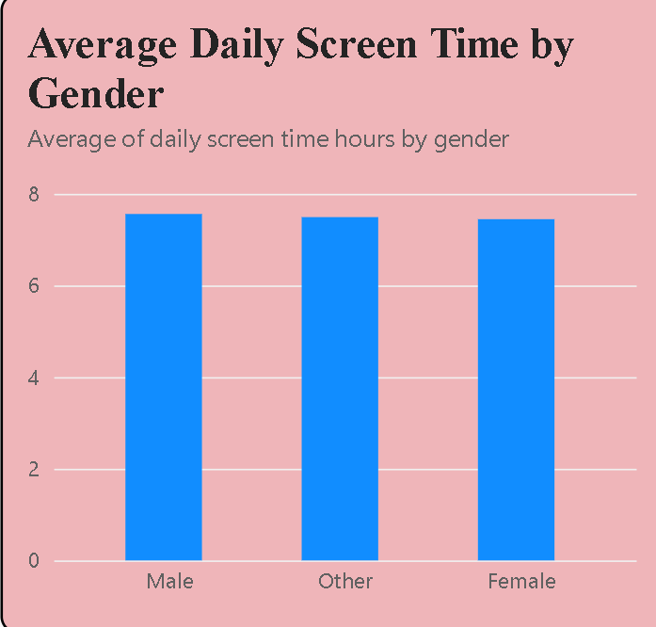

2. How many users belong to each specific digital addiction level?
- Visualization: Horizontal bar chart comparing user counts across Moderate, Severe, Mild, and None levels.
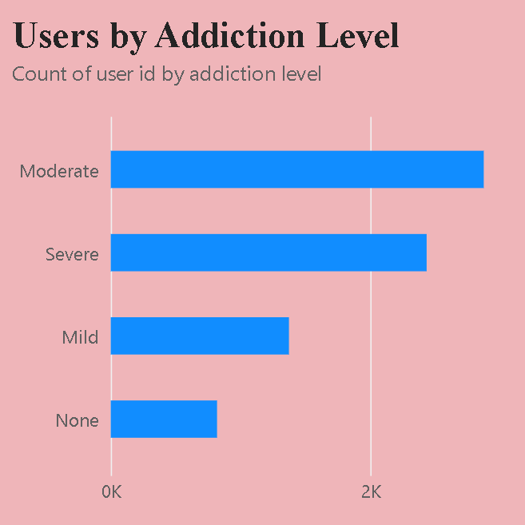
3. How does average daily screen time vary across different age groups?
- Visualization: Column chart tracking average daily screen time across groups: 30-39, 20-29, and Under 20.
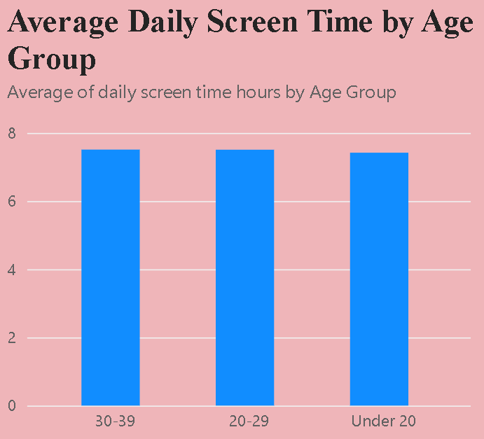

4. What is the distribution and proportion of addicted vs non-addicted users in the dataset?
- Visualization: Donut chart representing total tracked users (7.5K) divided into group 1 (29.23%) vs group 0 (70.77%).
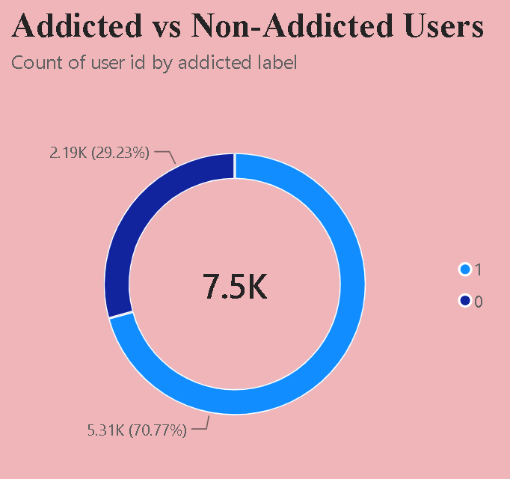
5. Is there a visible correlation or relationship between a user's daily screen time and their sleep hours?
- Visualization: High-density scatter plot distributing coordinates mapping sleep hours against daily screen time hours.
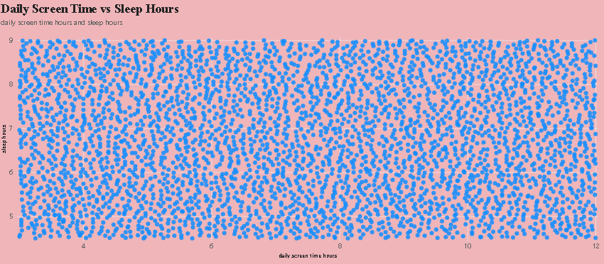

6. How does average gaming time compare directly to social media usage hours?
- Visualization: Comparative bar chart contrasting the average of social media hours with the average of gaming hours.
- 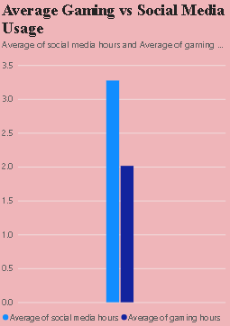

7. How can gender and addiction-level filters be used to view the dashboard dynamically?
- Visualization : Slicers – Gender and Addiction Level Shows the interactive filters available for Female, Male, Other and the addiction-level categories.

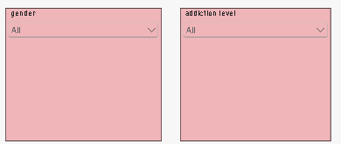

8. How can the dashboard be filtered by age group?
Visualization: Slicer – Age Group Shows the age-group filter available for 20–29, 30–39 and Under 20.

